Welcome new friend! Thank you for sharing in this time of worship with us! We invite you to consider making this your church home. Please, stay after worship for coffee in the Fellowship Hall and let us meet you! If you would like a friendly visit, prayer, or just information, please let us know, and we will make sure to let the pastor know. If you prefer, you may call the Office at (928) 772-6366.

Prelude & Procession of Light

Welcome & Announcements

Joys & Concerns

One: Lord, in your mercy,
ALL: hear our prayers
Opening Prayer

*Call to Worship
One: Lord Jesus, you know there are those among us who read the signs and know the best way forward.
ALL: Teach us to be wise when making decisions about God’s message to the people.
One: God has sent his light into the darkness, so all can see,
ALL: now he puts this same light in our hearts, so we may shar in Christ’s glory

*Opening Hymn Close to Thee (all vs)
UMH#407
CCLI #4308487
Old Testament reading: 1 Chronicles 12:32
New Testament reading: 2 Corinthians 4:3-10
Sermon Finding Our Prophetic Voice
Pastor Gary G Simons

Message in Music: Tell me the Stories of Jesus
(performed by the Prescott PVUM Choir)
Pastoral Prayer
Lord’s Prayer
Stewardship Moment/Giving of Our Gifts to God
Offering Invitation & Offering
*Doxology – Praise God, from Whom All Blessings Flow # 95 UMH
Offertory Prayer
*Song of Farewell: Lead Me, Lord (2x’s)
UMH#473
CCLI#22094
*Benediction
*Stand as you are able at these places in the service.
VOLUNTEER WORSHIP LEADERS
Today – 10/26/25 Next Week – 11/02/25
Liturgist: Dave McGrosso Mila Anderson
Ushers: Barb Brown
Greeters: Judy Reese
Fellowship: Ron & Judy Crandall Micheal Mefford & Carol Mason

Open Hearts…Open Minds…Open Doors
Prescott Valley United Methodist Church
8944 East Sommer Dr, Prescott Valley, AZ 86314
Email: prescottvalleyumc@gmail.com

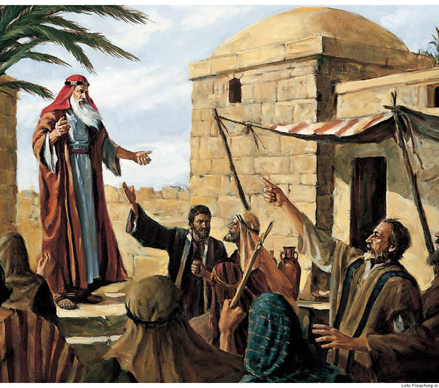


Connect with us by scanning the following QR
code with your smart phone camera.


Prescott Valley
United Methodist Church
Our Mission: Building relationships through our C.A.R.E.
Compassionate Community,
Attentive Hospitality,
Responsive Outreach, and
Engaging spiritual formation

Our Mission: Building relationships through our C.A.R.E.
Compassionate Community,
Attentive Hospitality,
Responsive Outreach, and
Engaging spiritual formation
October 26, 2025
Twentieth Sunday after Pentecost
PRAYERS; Michelle; Sharon P.; Sally J.; Kelly S.; Ron C.; Continued prayers for Mike P.; Pastor Amanda’s family; Christina and Jayden; Shelda & Gary S.; Gary W.; Marsha C.; Family of Jim H; Sharon P.; Peace in Israel & Gaza; Peace in the Ukraine.
JOYS: 9th Great Grandchild!
PRAY FOR OUR CHURCHES: All churches, especially New Song UMC Surprise, Az, Prescott UMC, Prescott, Az, Prescott Valley UMC, Prescott Valley, Az
MISSION OF THE MONTH: Yavapai County Food Bank

MARK YOUR CALENDAR:
Tuesday 10/28 Leadership Board Meeting 9:00 AM
Bible Study Ephesians 10:00 AM
Thursday 10/30 Cleaning Crew 8:00 AM
10/30 Caring Stitches 10:00 AM
Sunday 11/02 Adult Bible Study 9:00 AM
Communion

